1. Which of the following components of blood plays an important role in protection against invading microorganisms?

(a) leucocytes

(b) erythrocytes

(c) plasma

(d) platelets

2. Which of the following is **not** a function of the lymphatic system?

(a) Carries excess tissue fluid that leaks out of cells.

(b) Carries leucocytes to aid in defence against disease.

(c) Contains lymph nodes for the production of erythrocytes.

(d) Empties fluid into large veins in the upper chest.

3. The platelets role in blood clotting is to

(a) form threads of insoluble protein called fibrin.

(b) release a fluid called serum.

(c) stick to the rough surface of the blood vessels.

(d) remove metabolic wastes from the clot.

4. Which of the following sexually transmitted infections (STIs) is caused by a virus?

(a) gonorrhoea

(b) chlamydia

(c) syphilis

(d) genital herpes

Questions 5 – 7 refer to the diagram below showing the structures within a human body cell.

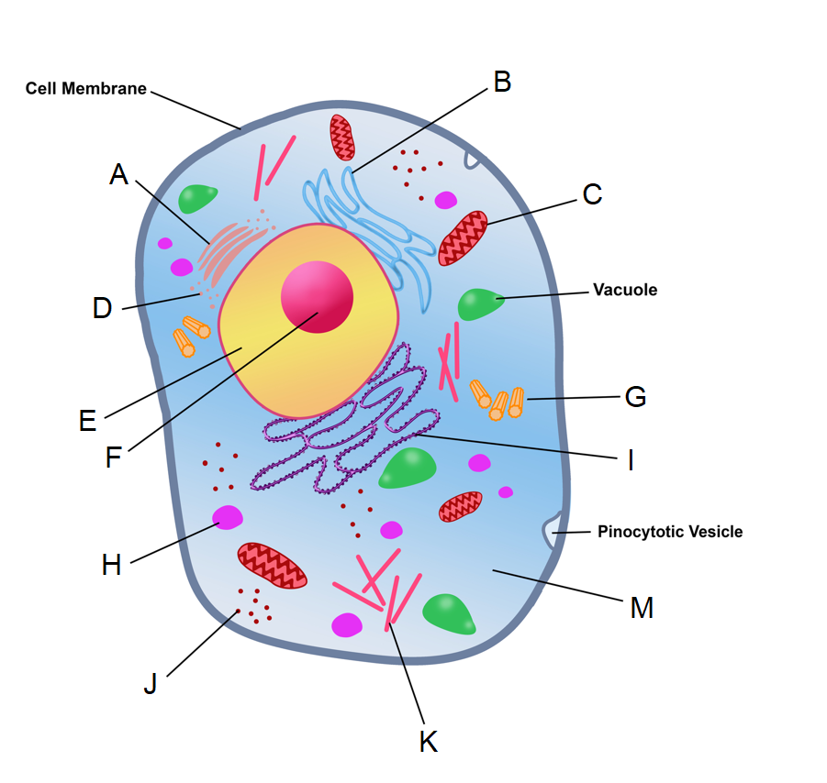

5. The structure labelled A is known as a

(a) Golgi apparatus.

(b) mitochondrion.

(c) centriole.

(d) microtubule.

6. The structures that form the spindle during mitosis and meiosis are indicated by which of the following labels?

(a) F

(b) J

(c) H

(d) G

7. Transcription takes place in which of the following parts?

(a) C

(b) E

(c) F

(d) M

8. The type of joint found where the humerus meets the ulna is best identified as a

(a) pivot joint.

(b) hinge joint.

(c) synovial joint.

(d) gliding joint.

9. Which of the following methods of contraception could be considered as a type of fertility awareness?

(a) the rhythm method

(b) coitus interruptus

(c) spermicides

(d) intrauterine devices

10. Which of the following structures is formed by the mesoderm during gestation?

(a) cartilage

(b) epithelium of the urinary bladder

(c) entire nervous system

(d) epidermis of the skin

11. A man with red-green colour blindness, a recessive condition caused by a mutated allele on the X chromosome, has children with a woman who is a carrier for the mutated allele. What is the probability they will have children with red-green colour blindness?

(a) 25%

(b) 50%

(c) 75%

(d) 100%

12. Fats, after digestion, are absorbed in the small intestine by

(a) simple diffusion into the blood capillaries.

(b) active transport into the blood capillaries.

(c) simple diffusion into the lacteals.

(d) active transport into the lacteals.

Questions 14 and 15 refer to the diagram below of a nephron.

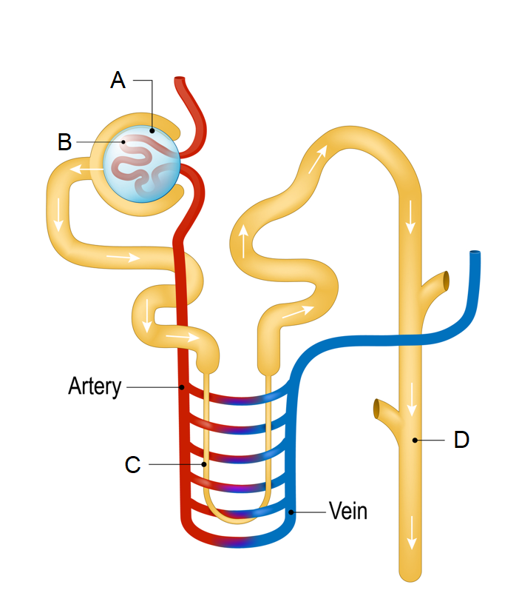

13. Which of the following processes occurs at the part labelled C?

(a) Active reabsorption of water.

(b) Secretion of hydrogen and potassium ions.

(c) Formation of filtrate.

(d) Passive reabsorption of water by osmosis.

14. Which of the following parts would have the highest concentration of glucose?

(a) A

(b) B

(c) C

(d) D

15. Mothers can help protect their unborn children from a condition called spina bifida by increasing their intake of which of the following nutrients during pregnancy?

(a) vitamin A

(b) calcium

(c) folic acid

(d) fluoride

16. The type of stem cells with the greatest level of potency are

(a) totipotent cells.

(b) pluripotent cells.

(c) multipotent cells.

(d) haemopoietic cells.

Questions 18 – 20 refer to the data shown in the table below.

**Table 1: Activity of the digestive enzyme pepsin as a percentage of its maximum**

|  |  |
| --- | --- |
| **pH** | **Activity of pepsin (%)** |
| 1.0 | 0 |
| 1.5 | 65 |
| 3.0 | 100 |
| 5.0 | 20 |
| 5.5 | 0 |

17. Which of the following could be considered a testable hypothesis for the experiment that generated this data?

(a) Pepsin works best in the stomach.

(b) The higher the pH, the greater the activity of pepsin.

(c) The activity of pepsin can be affected by pH levels.

(d) All digestive enzymes work best at a low pH.

18. This data could be transformed into a

(a) histogram.

(b) column graph.

(c) scatter plot.

(d) line graph.

19. The enzyme that is used to unwind DNA during DNA replication is known as

(a) DNA polymerase.

(b) RNA polymerase.

(c) DNA helicase.

(d) DNA ligase.

20. An increase in the concentration of a substrate in a chemical reaction

(a) will slow down the rate of reaction.

(b) will continually increase the rate of reaction.

(c) will initially increase rate of reaction until saturation occurs.

(d) will initially slow down rate of reaction until saturation occurs.

21. Which of the following correctly states the mode of inheritance for Huntington’s disease?

(a) X-linked, recessive

(b) autosomal, recessive

(c) X-linked, dominant

(d) autosomal, dominant

22. During inhalation

(a) the intercostal muscles relax, and pull the ribs up and out.

(b) the diaphragm relaxes, and increases the volume of the thoracic cavity.

(c) the intercostal muscles contract, and pull the ribs up and out.

(d) the diaphragm contracts, and decreases the volume of the thoracic cavity.

23. During menstruation, which of the following statements about hormones is correct?

(a) The levels of progesterone in the blood decrease, as the levels of FSH increase.

(b) The levels of progesterone in the blood increase, as the levels of FSH decrease.

(c) The levels of progesterone and FSH in the blood both increase.

(d) The levels of progesterone and FSH in the blood both decrease.

Questions 28 - 30 refer to the diagram below showing the digestive system.

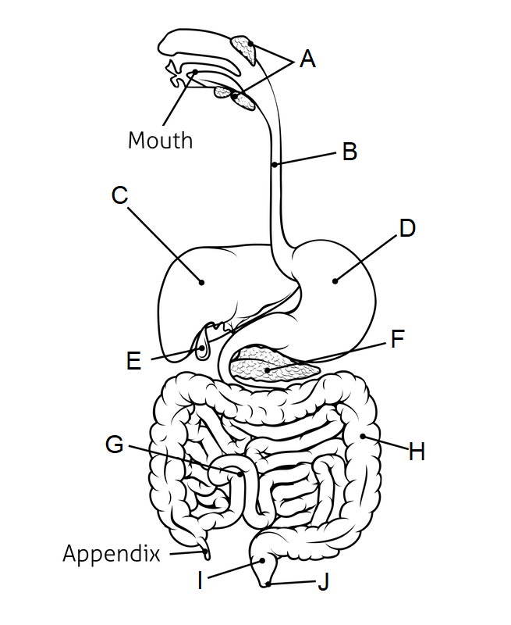

24. The part labelled F is the

(a) liver.

(b) stomach.

(c) pancreas.

(d) gall bladder.

25. Chemical digestion of proteins begins in

(a) the mouth.

(b) B.

(c) C.

(d) D.